**NAAN MUDHALVAN**

**ASSIGNMENT DOCUMENT**

**COURSE TITLE** : DIGITAL MARKETING

**COLLEGE CODE** : 1105

**COLLEGE NAME** : GOJAN SCHOOL OF BUSINESS AND TECHNOLOGY

**NM ID** : 383BEBB37DFE432AAD841EBCF7B667E5

**NAME** : LOGANATHAN M

**REGISTER NUMBER** : 110520106006

**YEAR** : 4TH YEAR

**DEPARTMENT** : ELECTRONICS AND COMMUNICATION ENGINEERING

1. Create a blog or website using Blogspot and Wordpress. Customize the theme design and post new article with 500 words.

Link: https://lmfitnessacaddmy.blogspot.com/2023/10/lm-fitness-academy.html



2.create a New Facebook Business Page and post one social media poster for your brand.

Link:https://www.facebook.com/profile.php?id=61552746714954&mibextid=9R9pXO

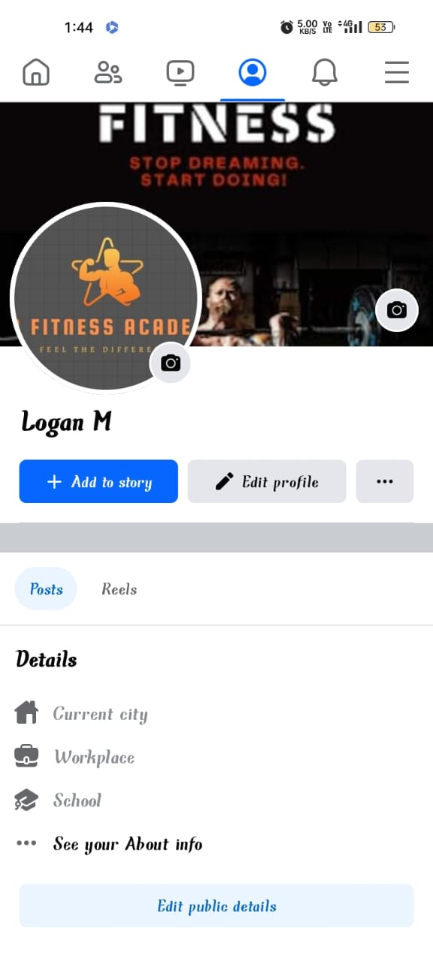

3.*Create* and design a social media advertisement poster using canva

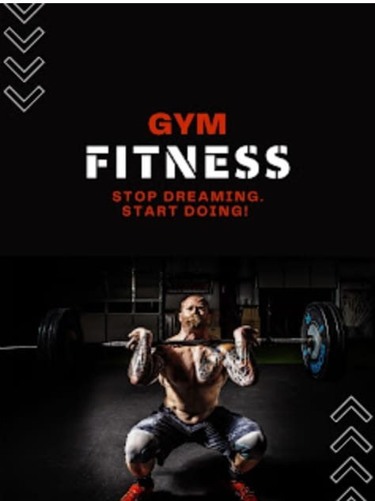

4.Create email newsletter design using MailChimp or canva tool.

Link: <https://lmfitnessacaddmy.blogspot.com/2023/10/lm-fitness-academy-newsletter.html>

